Quality Hold Level 2 Technical Specifications

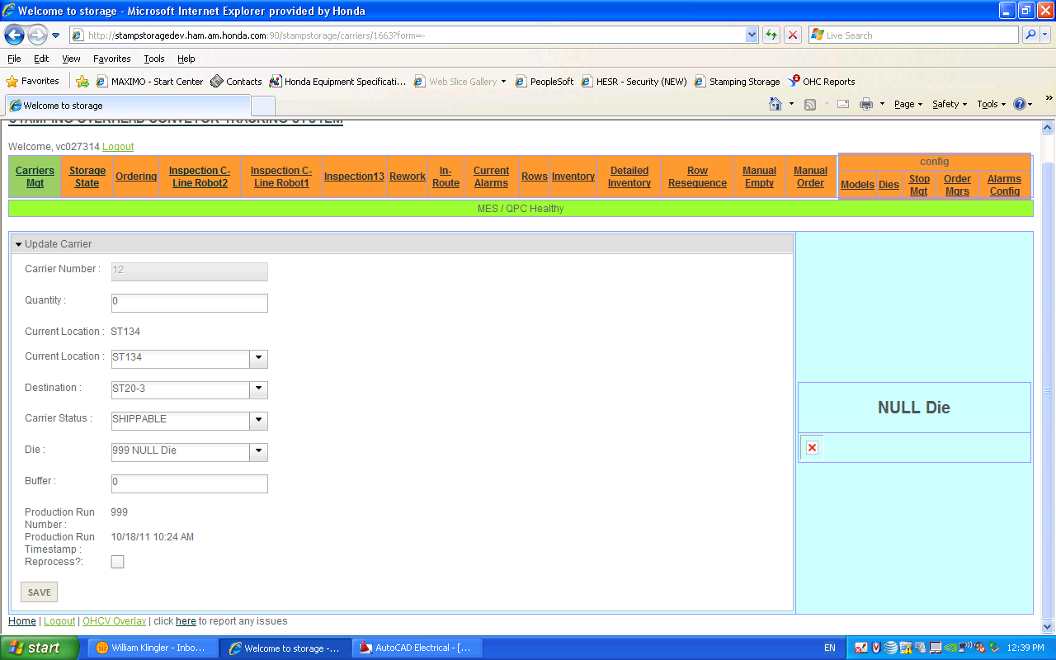
Screen Mockup from Stamping
Add defect edit that will affect this carrier and all carriers put on lot hold or QC
Production run number of this carrier
Put this production run on QC / hold
Put this carrier and the previous # of carriers on hold. Enter value
Put this carrier and the next # of carriers on hold. Enter value
Save button will implement all changes
Put a row on QC or hold enter row #
Remove a row on QC or hold enter row #

T
Proposed Carrier Update Screen
Save button will implement all changes
Button1
New button added to bottom of carrier update screen
Add Defect
Remove

Business Requirements
- Need to be able to place an entire production run on hold/ quality check
- Need to be able to place an entire row on hold/quality check
- Need to be able to place a number of carriers prior to carrier number and after the carrier number on hold/quality check within the current production run
- Would like certain carriers assigned to a weld line because of oil film on the blank is a quality issue for paint line 1, these parts should go to weld line 1.
  - If defect of the oil film shows up it should only send these carriers to Weld line 1
  - Potential to add a new status for affinity of weld line 1 and weld line 2
- Check ST13 pushbutton carrier release is a oneshot. These button send a trigger to the mes to release a carrier that is on Quality check. Has to have destination of one of consumer lines
  - Carrier has parts, doesn’t have parts, has just been inserted into the system at last reader
  - Hold status is being removed when passes stop 13. Would like this to remain there if its not going to a consumer line.
  - Status changed to shippable instead of inspection required if it came through and was push buttoned through and has consumer destination.
    - If it is not ok it should be recirculated back into the row.
    - If it is recirculated then the batch will be one short and it will have quantity not going down and so the count will heal
    - PLC work to change the status for M9000 for PLC updating items not current location or update date. Register will set status to shippable. Test carrier cycle through stop 13 in auto and manual.
New Screen Mockup Group Update
Put this production run on inspection required / hold
Put row on inspection required or hold
Put the previous # of carriers on inspection required/ hold. Enter value
Put thethe next # of carriers on inspection required/ hold. Enter value
Remove this row on QC or hold
Remove this production run on inspection required / hold
Prod Run Number dropdown
Updateable timestamp
Status
Submit

New Screen Group Update Confirm
Model
Save button will implement all changes
Current Location
Carrier #
Save
Model
Current Location
Carrier #
Model
Current Location
Carrier #
Model
Current Location
Carrier #
Model
Current Location
Carrier #
Add Defect
Remove
Remove
Remove
Remove
Remove
Remove
The carriers below will be changed to the following status
Status
Cancel
Message field
System Requirements
- Carrier Update Screen Modifications
  - Defect List
    - Add Defect
      - Will add the defect to the entire list
    - Remove Defect
      - Will remove the defect from the list of defects that will be added to the entire list
    - Modify defect
      - Will allow the defect to be updated or changed
  - Button1
    - Text will display “Update Group”
    - On Click
      - Submit current carrier Update
      - Go to Update Group Screen
- Update Group Screen
  - Prod Run Number drop down
    - Will be a dropdown
    - Contains only production run numbers that still have active parts
    - Default
      - Blank if access this screen from Group hold link
      - The production run number from carrier update if accessed from update carrier
  - CheckBox put this production run on Inspection Required or Hold
    - Will place the entire production of carriers with production run same as Prod Run Number Drop down on Inspection Required or hold depending upon the status field
    - Will only place carriers with product on hold or inspection required
      - Note this means if production run is still ongoing it will only put carriers that have been completed from press on hold or inspection required
    - Will update to inspection required or hold based upon status field
    - Will not be available if status field is set to shippable
    - Will only affect carriers that have parts on them
    - Will set status field to only have the selections for inspection required or hold – Default of hold
    - Will not be available if production run number is blank
  - CheckBox remove this production run on inspection required or Hold
    - Will remove the entire production run of carriers with production run same as Prod Run Number Drop down
    - Will set status field to shippable
    - Will not be available if status field is set to inspection required or hold
    - Will not be available if production run number is blank
  - Updateable timestamp
    - Will be a date/time selector
    - Format mm/dd/yy hh:mm:ss
    - Default
      - If sent from update carrier will be the update timestamp from the carrier
      - Otherwise blank
      - Will not be available if status is set to shippable
      - Will set status field to inspection required or hold available fields
    - Will not be available if run number is blank
  - TXT Previous carriers
    - Text box accepts only numeric value up to 999
    - Will select a number of carriers prior to the timestamp on this production run to put them on inspection required or hold based upon status field
      - Note this means if production run is still ongoing it will only put carriers that have been completed from press on hold or inspection required
    - Will only impact carriers of same production run
    - Will only impact carriers with product on them
    - Will not be available if status field is set to shippable
    - Will set available options for status to inspection required or shippable
    - Will not be available if date timestamp is not set
  - TXT After carriers
    - Text box accepts only numeric value up to 999
    - Will select a number of carriers prior to the timestamp on this weld line to put them on inspection required or hold based upon status field
      - Note this means if production run is still ongoing it will only put carriers that have been completed from press on hold or inspection required
    - Will only impact carriers of same production run
    - Will only impact carriers with product on them
    - Will not be available if status field is set to shippable
    - Will set available options for status to inspection required or shippable
    - Will not be available if date timestamp is not set
  - Dropdown put this row on Inspection required or Hold
    - Defaults
      - Current location of carrier if sent from update carrier and carrier is in a row
      - Blank otherwise
    - Will place the entire row of carriers with current location same as current carrier on hold or inspection required
      - If carriers are not yet in row will not place them on hold
      - If production run number is selected it will only place carriers with that production run number on hold otherwise it will place the entire row
    - Will only place carriers with product on hold or inspection required
    - Will choose hold or inspection required based upon status selected for current carrier
    - Will not be available if status is set to shippable
    - Will set available options for status to inspection required or hold
  - Dropdown remove this row on QC or Hold
    - Defaults
      - Current location of carrier if sent from update carrier and carrier is in a row
      - Blank otherwise
    - Will not be available if status is set to inspection required or hold
    - Will place the entire row of carriers with current location same as current carrier as Shippable
      - If production run number is set will only select those in production run number
      - Else will select the entire row
    - If carriers are not yet in row will not change status
  - Button Submit
    - Will select all carriers meeting criteria established
      - If production run number is set will add an “AND” condition to the selection criteria of row, carriers after, and carriers previous
      - Will have an or condition set for selection criteria of row, carriers after, carriers previous
        - Means if a row is set and carriers before and carriers after is set it will create a selection list with all of that criteria
    - Then it will redirect to the Group Update Confirm Screen
- Group Update Confirm Screen
  - Message Field
    - Display a message stating, “ The following carriers are in Weld”
    - Then list the carrier numbers
  - Status
    - Contains the status from the previous page
  - Contains a list of carriers with the following fields
    - Carrier #
    - Model
    - Current location
    - Remove button
      - Will be a button that will allow that carrier to be removed from the list
  - Defect List
    - When selecting a group all defects for said group will be added to the list
    - The list is then verified with ability to add or remove defects for the group in its entirety
    - Add Defect
      - Will add the defect to the entire list
    - Remove Defect
      - Will remove the defect from the list of defects that will be added to the entire list
  - Save button
    - Will change the status of all carriers in the list to the status field
    - Will add the defects in the defect list to all carriers if changing the status to hold or inspection required
      - If defect already exists will not add it again
    - Then takes the user to the default carrier management screen
  - Cancel button
    - Returns user to previous group update screen with selection criteria
- Inventory screen update
  - Field 1
    - Added to each individual section
    - Contains the number of carriers on hold for each section
    - Text =”On Hold”
  - Field 2
    - Added to each individual section
    - Contains the number of carriers on hold for each section
    - Text =”Inspection Required”
- Inspection screen update
  - Button1
    - Text will display “Update Group”
    - On Click
      - Submit current carrier Update
      - Go to Update Group Screen
- Other ways to remove hold
  - Inspection screen change status from hold to shippable
  - Manual carrier update change status from hold to shippable
  - Checkbox to remove hold from row on current carrier or another carrier within the row was checked and submit button checked
  - Checkbox to remove hold from production run on current carrier or another carrier within the production run was checked and submit button checked
  - Carrier passes inspection station 13 with a delivery point of consumer area (i.e. Weld1, Weld2, KD)
  - Carrier passes the press inspection point with a delivery point of consumer area
- Defect Archive table
  - Creation of a defect archive table
  - Will mirror current defect table in all ways
  - Will not have a deletion process
- Archival Process
  - When carrier goes empty select from current defect table all defects associated with current carrier will be selected
  - An insert into an archival table will be made with the current selection criteria
  - A select from the archival table with the new defects will be made
  - A comparison of the two selects is performed.
  - Once it is confirmed the data is in the archive table
  - Data will be removed from the current defect table
- Other notes
  - Carrier will still move around in the system if it is on hold it just will not be available to go to consumer area unless it is inspected
  - Hold means it can move around but not be shipped
  - Inspection required can be shipped but will require a stop at 13 to be inspected unless its destination is 7-4 to be recirculated.
  - The defect will not be removed from the carrier until it becomes empty
  - If production run is still going will need to run the process more than once as it can only select the carriers that have product on them
- User Groups
  - Inspector user group
    - Does not have the ability to update anything in the system
  - Team Leader/ Coordinator
    - Gains access to add defects to carriers at inspection screen and carrier management screen
- Discussion points when meeting with team leaders in Weld
  - Define processes around how system should be working for hold functionality
    - Should we email carriers on hold to off going shift?
    - Would like these questions answered when we perform final signoff
    - Who should have access to these points?

Inventory Screen update
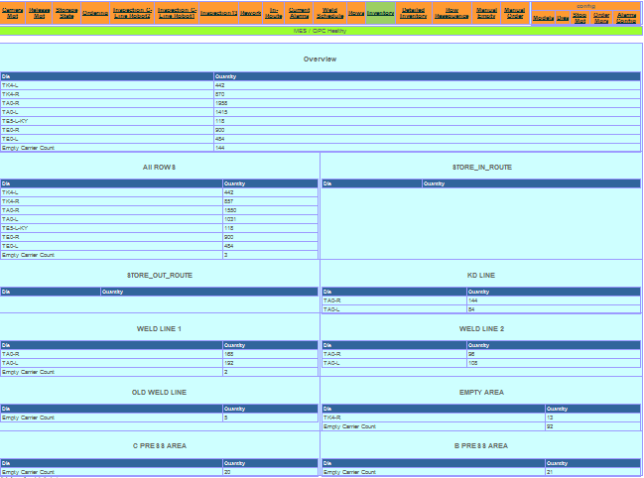
Field1
Field2
Field1
Field2
Field1
Field2
Field1
Field2
Field1
Field2
Field1
Field2
Field1
Field2
Field1
Field2
Field1
Field2
Field1
Field2
Field1
Field2
Inspection Screen update
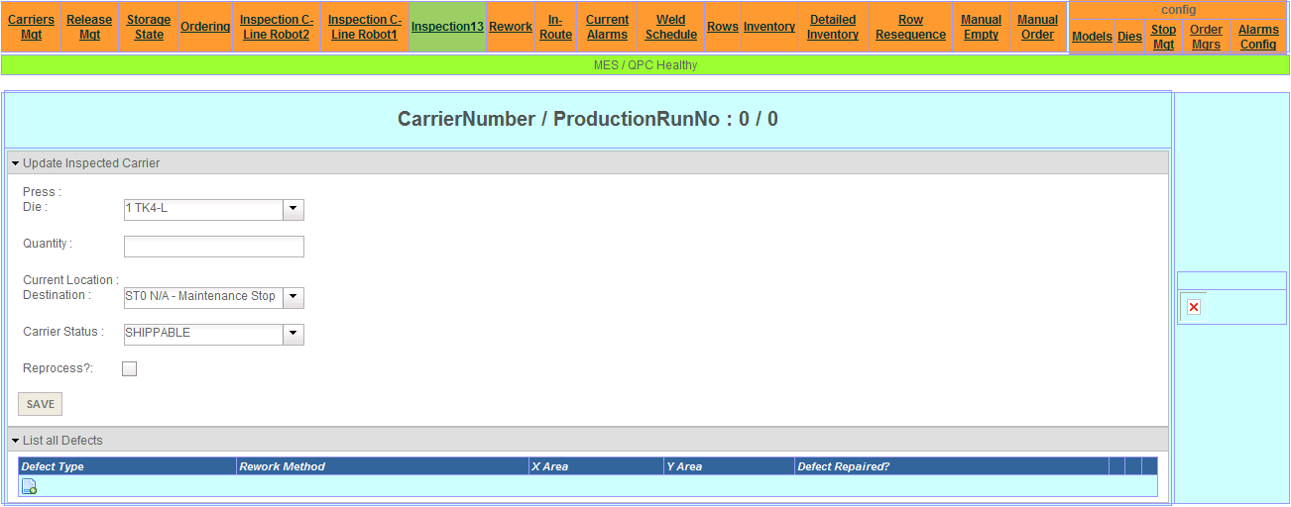
Button1

